4th Sunday of Easter
CHRIST LUTHERAN CHURCH | Lodi, California
April 21, 2024

WELCOME TO WORSHIP
Welcome to Christ Lutheran Church. We pray that your soul will be strengthened by the good news about God’s grace, love, and forgiveness given to us. If you would like to learn more about our church, please speak with our pastor or one of our members after the service.
- Bathrooms are located in the fellowship hall. A changing table is located in the women’s bathroom.
WORSHIP THEME
Jesus is our Good Shepherd. Through his Word, he has called us into his flock. Now he cares for us and dwells with us. Because he has risen from the dead and ascended to God’s right hand, he is able to be present with us everywhere we go; to comfort us in any danger or difficulty; and to finally bring us out of the valley of the shadow of death and into his eternal dwelling.
The Service of the Word and Sacrament
The high and holy worship of God is faith in Jesus Christ. Such faith is created and sustained by God’s service to us (the German, “Gottesdienst,” “God/Divine Service). In the Divine Service, the Lord comes to us in His Word and Sacrament to bless and enliven us with His gifts. The Service is not something we do for God, but His service to us received in faith. The liturgy is God’s work. He gives, we receive.
HYMN Jesus, Shepherd of the Sheep| CW 436

INVOCATION
M: The grace of our Lord ✙ Jesus Christ and the love of God and the fellowship of the Holy Spirit be with you.
C: And also with you.
CONFESSION
M: God invites us to come into his presence and worship him with humble and penitent hearts. Therefore, let us acknowledge our sinfulness and ask him to forgive us.
From God’s Word we know that wherever God puts His name, there He is to bless. In the Old Testament the temple was the place where God graciously caused His name to be present (1 Kings 8:27-30).
God has put His name —Father, Son, and Holy Spirit—on us in Holy Baptism. The Divine Service begins with the Invocation, the words spoken over us at our baptisms. Every Divine Service is for the hallowing of the Lord’s name, which the Small Catechism reminds us is done “when the Word of God is taught in its truth and purity, and we, as the children of God, also lead holy lives according to it” (Matthew 28:18-20).
C: Holy and merciful Father, I confess that I am by nature sinful, and that I have disobeyed you in my thoughts, words, and actions. I have done what is evil and failed to do what is good. For this I deserve your punishment both now and in eternity. But I am truly sorry for my sins, and trusting in my Savior Jesus Christ, I pray: Lord, have mercy on me, a sinner.

absolution
M: God, our heavenly Father, has been merciful to us and has given his only Son to be the atoning sacrifice for our sins. Therefore, as a called servant of Christ and by his authority, I forgive you all your sins in the name of the Father and of the Son ✙ and of the Holy Spirit.
C: Amen
LORD, HAVE MERCY - Kyrie
M: For all that we need in life and for the wisdom to use all your gifts with gratitude and joy, hear our prayer, O Lord.
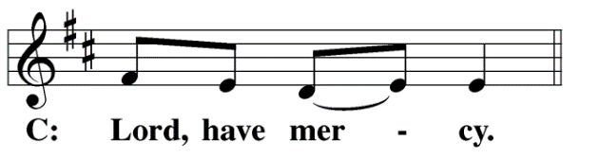
M: For the steadfast assurance that nothing can separate us from your love and for the courage to stand firm against the assaults of Satan and every evil, hear our prayer, O Christ.
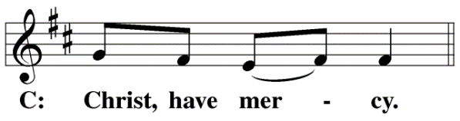

M: For the well-being of your holy Church in all the world and for those who offer here their worship and praise, hear our prayer, O Lord.
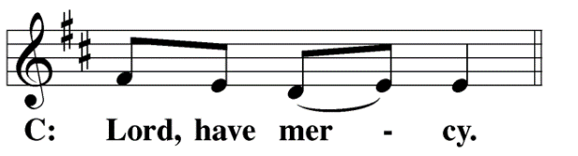
M: Merciful God, maker and preserver of life, uphold us by your power and keep us in your tender care:
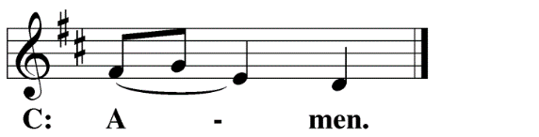
M: The works of the Lord are great and glorious; his name is worthy of praise.
O LORD, OUR LORD
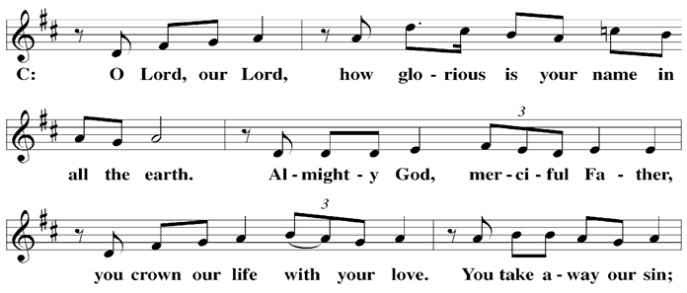

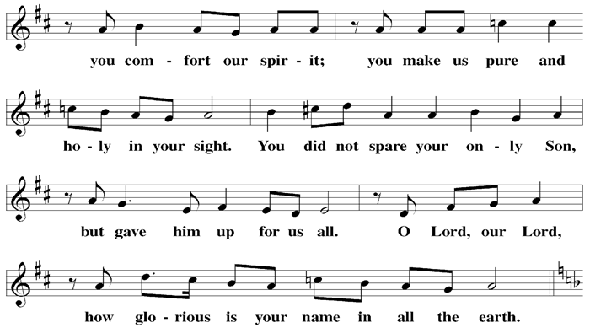

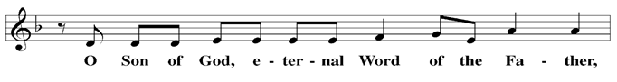

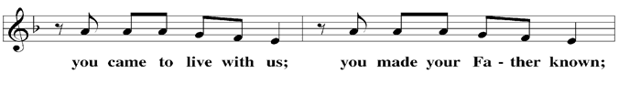

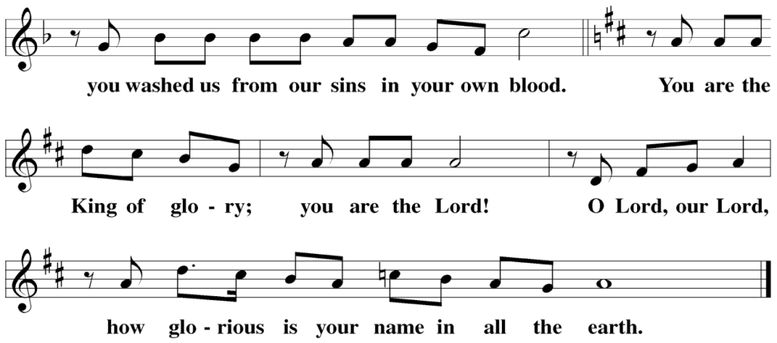

The Service of the Word
Having just received absolution for their sins, believers now gather around the Word of God to find encouragement and peace for their lives on earth.
PRAYER OF THE DAY
M: Let us pray.
O Lord Jesus Christ, you are the Good Shepherd who laid down your life for the sheep. Lead us now to the still waters of your life-giving Word that we may abide in your Father’s house forevermore; for you live and reign with him and the Holy Spirit, one God, now and forever.
C: Amen
FIRST LESSON Acts 20:28–32
The Apostle Paul commissions the elders of the church in Ephesus, and commends them to God’s care.
²⁸ Keep watch over yourselves and all the flock of which the Holy Spirit has made you overseers. Be shepherds of the church of God, which he bought with his own blood. ²⁹ I know that after I leave, savage wolves will come in among you and will not spare the flock. ³⁰ Even from your own number men will arise and distort the truth in order to draw away disciples after them. ³¹ So be on your guard! Remember that for three years I never stopped warning each of you night and day with tears.
³² “Now I commit you to God and to the word of his grace, which can build you up and give you an inheritance among all those who are sanctified.

PSALM Psalm 23

23F My Shepherd Will Supply My Need Psalm 23F
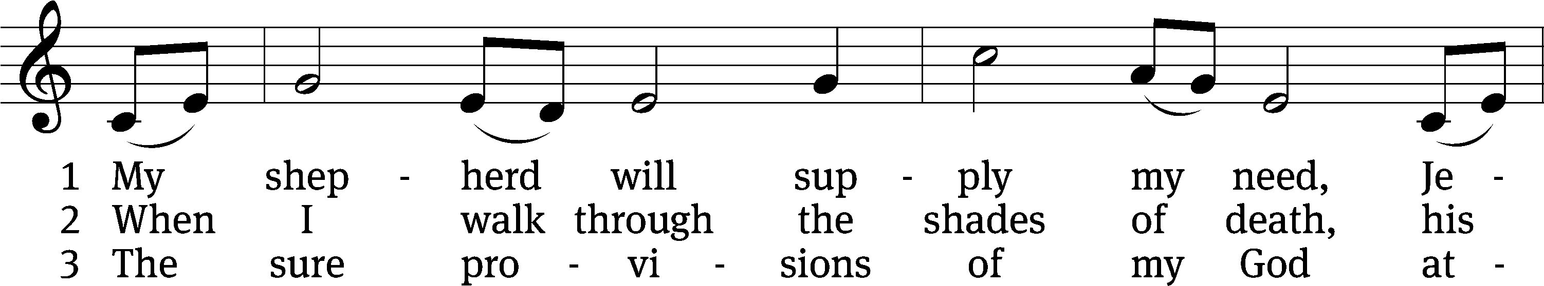
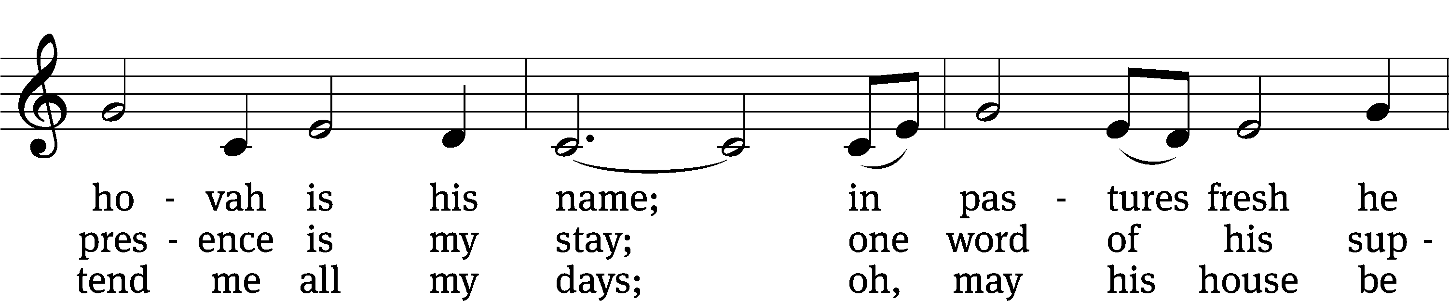
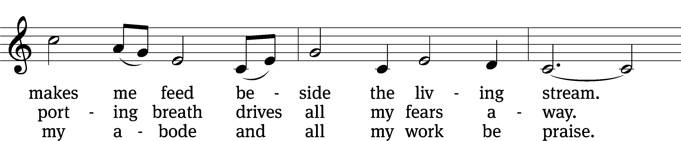
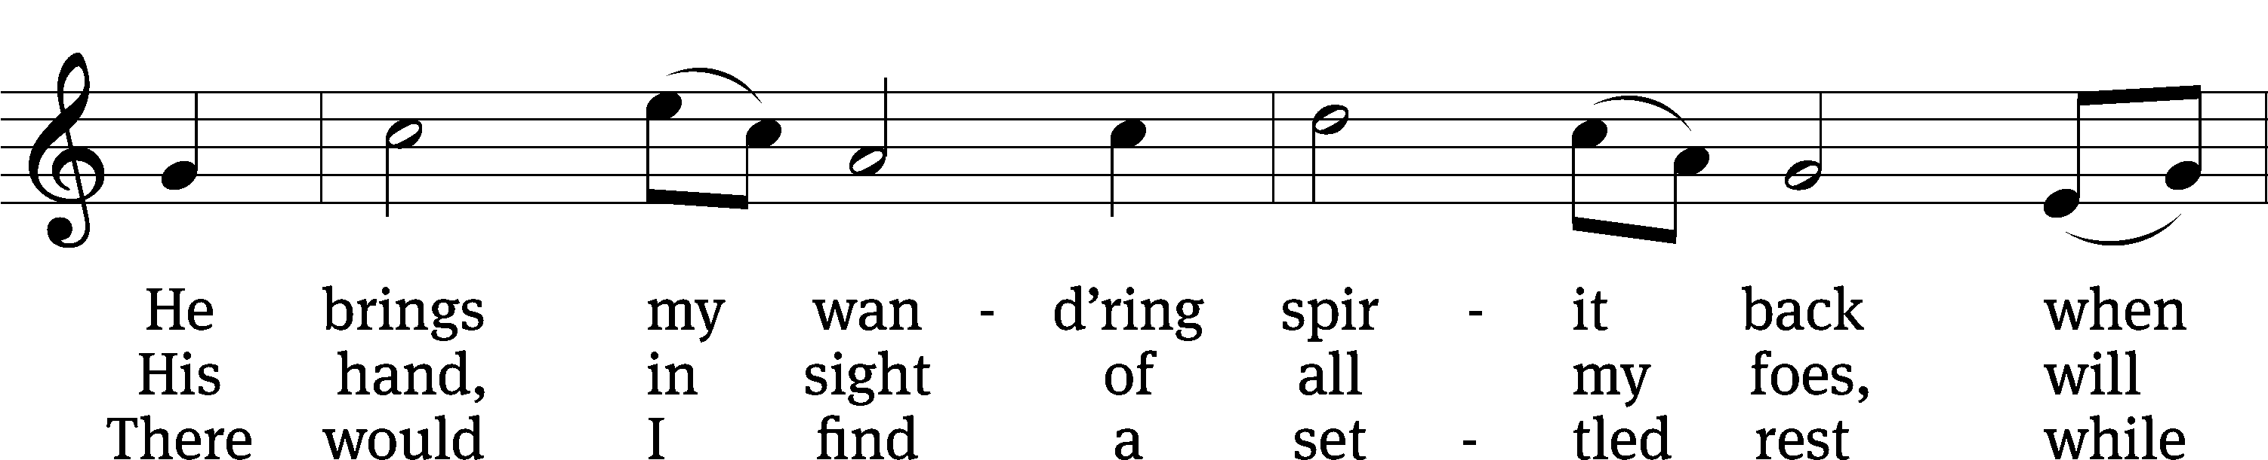
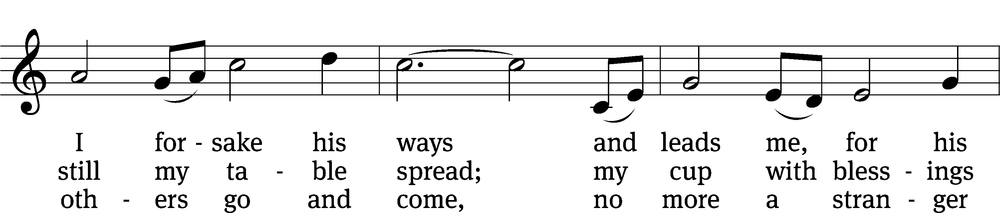
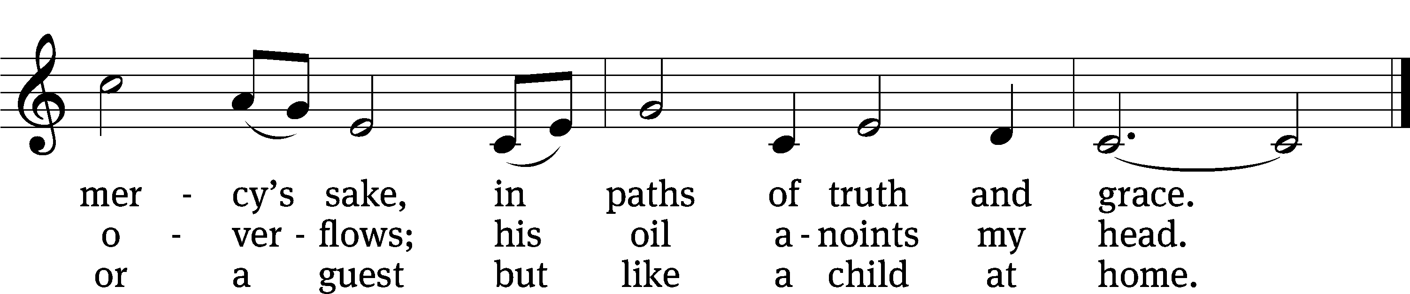
Text: Isaac Watts, alt.
Tune: Southern Harmony, 1835, ed. William Walker
Text and tune: Public domain
SECOND LESSON 1 Peter 5:1–4
Jesus’ representatives imitate Christ.
5 To the elders among you, I appeal as a fellow elder and a witness of Christ’s sufferings who also will share in the glory to be revealed: ² Be shepherds of God’s flock that is under your care, watching over them—not because you must, but because you are willing, as God wants you to be; not pursuing dishonest gain, but eager to serve; ³ not lording it over those entrusted to you, but being examples to the flock. ⁴ And when the Chief Shepherd appears, you will receive the crown of glory that will never fade away.
VERSE OF THE DAY John 10:14
M: Alleluia, alleluia. Christ is risen!
C: He is risen indeed! Alleluia!
M: I am the good shepherd; I know my sheep and my sheep know me.
C: Alleluia!
THE GOSPEL John 10:11–18
Jesus is our Good Shepherd.
¹¹ “I am the good shepherd. The good shepherd lays down his life for the sheep. ¹² The hired hand is not the shepherd and does not own the sheep. So when he sees the wolf coming, he abandons the sheep and runs away. Then the wolf attacks the flock and scatters it. ¹³ The man runs away because he is a hired hand and cares nothing for the sheep.
¹⁴ “I am the good shepherd; I know my sheep and my sheep know me— ¹⁵ just as the Father knows me and I know the Father—and I lay down my life for the sheep. ¹⁶ I have other sheep that are not of this sheep pen. I must bring them also. They too will listen to my voice, and there shall be one flock and one shepherd. ¹⁷ The reason my Father loves me is that I lay down my life—only to take it up again. ¹⁸ No one takes it from me, but I lay it down of my own accord. I have authority to lay it down and authority to take it up again. This command I received from my Father.”

M: This is the Gospel of the Lord.
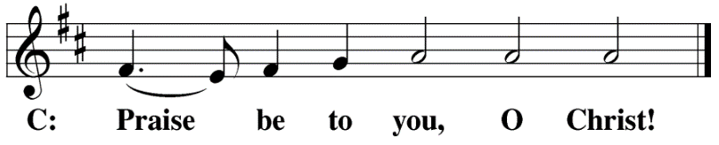

HYMN OF THE DAY The King of Love My Shepherd Is| CW 375
SERMON 1 Kings 19
NICENE CREED
Having heard the Word of God, we confess our faith in His name. The creed is our saying back to God what He has first said to us. In the Creed we acclaim the truth of the triune God and His work of salvation accomplished for us in His incarnate Son, Jesus Christ.
We believe in one God, Dt. 6:4
the Father, the Almighty, 2 Cor. 6:18
maker of heaven and earth, Is. 51:13
The Nicene Creed is the great Confession of the Christian faith professed by all Christians. The Creed originated at the First Council of Nicaea (c. AD. 325)
of all that is, seen and unseen. Col. 1:16
We believe in one Lord, Jesus Christ, 1 Cor 8:6
the only Son of God, Jn. 3:16
eternally begotten of the Father, Heb. 1:2,5
God from God, Light from Light, true God from true God, Jn. 1
begotten, not made, of one being with the Father. Jn. 10:30
Through him all things were made. Jn. 1:3
For us and for our salvation, 1 Th. 5:9
he came down from heaven, Jn. 6:38
was incarnate of the Holy Spirit and the virgin Mary, Lk. 1:35
The Creed itself was crafted as a confession of Scripture in opposition to the Arian heresy, which denied that the Lord Jesus and the Holy Spirit are God.

and became fully human. Gal. 4:4
For our sake he was crucified under Pontius Pilate. Mk. 15:15
He suffered death and was buried. 1 Cor. 15:3-4a
On the third day he rose again in accordance
with the Scriptures. 1 Cor. 15:4b
He ascended into heaven Ac. 2:33-34
and is seated at the right hand of the Father. Heb. 1:13
He will come again in glory Mt. 25:31
to judge the living and the dead, 2 Tim. 4:1
and his kingdom will have no end. Lk. 1:33

We believe in the Holy Spirit, the Lord, the giver of life, Job 33:4
who proceeds from the Father and the Son, Jn. 15:26
who in unity with the Father and the Son Jn. 4:24
is worshiped and glorified,
who has spoken through the prophets. 2 Pet. 1:25
We believe in one holy Christian Mt. 16:18; Eph. 2:19-20
and apostolic Church.
We acknowledge one baptism for the forgiveness of sins. Eph. 4:5; Ac. 2:38
We look for the resurrection of the dead 1 Cor. 15:21-22
and the life of the world to come. Amen. Rev. 22

OFFERING
In response to God’s love and forgiveness, we give back a portion of what he has given us. The members of Christ Lutheran Church have joined to proclaim the gospel to this community. These offerings support that work. While our guests are welcome to participate, they should not feel obligated to do so.
PRAYER OF THE CHURCH
M: Lord Jesus, Good Shepherd, we have heard the sweet sound of your familiar and loving voice in the gospel and have feasted in the green pastures of your Holy Word. We will soon taste from the table of your grace which you have prepared before us in your body and blood. Use this gospel in Word and Sacrament to nourish and sustain us as we journey through this life. What joy we have to know that you have laid down your life and taken it up again for the sake of your flock.
Gracious Shepherd, without you we are confused and foolish. Forgive us for the time we wander from you and stray from the call of your voice. Restore us to your fold, and protect us from the evil one. When Satan comes in the sheep’s clothing of false teaching, expose his lies and guide us in your truth. Use your rod and staff to curb our sinful nature and lead us in paths of righteousness.
Bless your Church with faithful under-shepherds: pastors, teachers, and other representatives who proclaim your death and resurrection as they care for your flock. Bless pastors with zeal and wisdom. Grant your spirit also to our Synod and district presidents, as well as our circuit pastor, who guard not only their own congregations, but also many other souls entrusted to their care. Use the faithful witness of your people to gather your other sheep into your fold. Make the work of these servants a joy and not a burden.
Bless us with representatives, administrators, and servants in every level of government. May they use their powers to curb evil and promote good. Drive all danger away from your people everywhere, and bestow peace upon your world. When your people must walk through the valley of the shadow of death, let them know that you walk with them, and they need fear no evil.
Look with your tender care upon all who suffer pain, loss, loneliness, or other afflictions of body and soul. Comfort them with your presence, anoint them with the comfort of your resurrection and the peace that passes understanding. Make their cups overflow with your grace, and finally usher them into your house, where they may dwell forever.
May your mercy and love follow us all the days of our life. Hear us for your name’s sake; for you live and reign with the Father and the Holy Spirit, one God now and forever.
C: Amen.

LORD’S PRAYER Matthew 6:9-13; Luke 11:2-4
C: Our Father, who art in heaven, hallowed be thy name,
thy kingdom come, thy will be done
on earth as it is in heaven.
Give us this day our daily bread;
and forgive us our trespasses, as we forgive those
who trespass against us;
and lead us not into temptation, but deliver us from evil.
For thine is the kingdom and the power
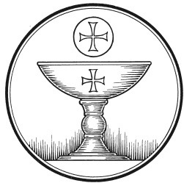
and the glory forever and ever. Amen.

The Service of the Sacrament
This greeting marks a new service, so to speak. These ancient introductory words & phrases help to highlight, celebrate and bring attention to the Sacrament.
M: The Lord be with you.
C: And also with you.
M: Lift up your hearts.
C: We lift them up to the Lord.
M: Let us give thanks to the Lord our God.
C: It is right to give him thanks and praise.
M: Praise to the God and Father of our Lord Jesus Christ! In love he has blessed us with every spiritual blessing. He raised Christ from the dead and seated him at his right hand in the heavenly realms and placed all things under his feet for the benefit of the Church. Now have come the salvation and the power and the kingdom of our God and the authority of his Christ. To him who sits on the throne and to the Lamb be praise and thanks and honor and glory for ever and ever:

HOLY, HOLY, HOLY – Sanctus
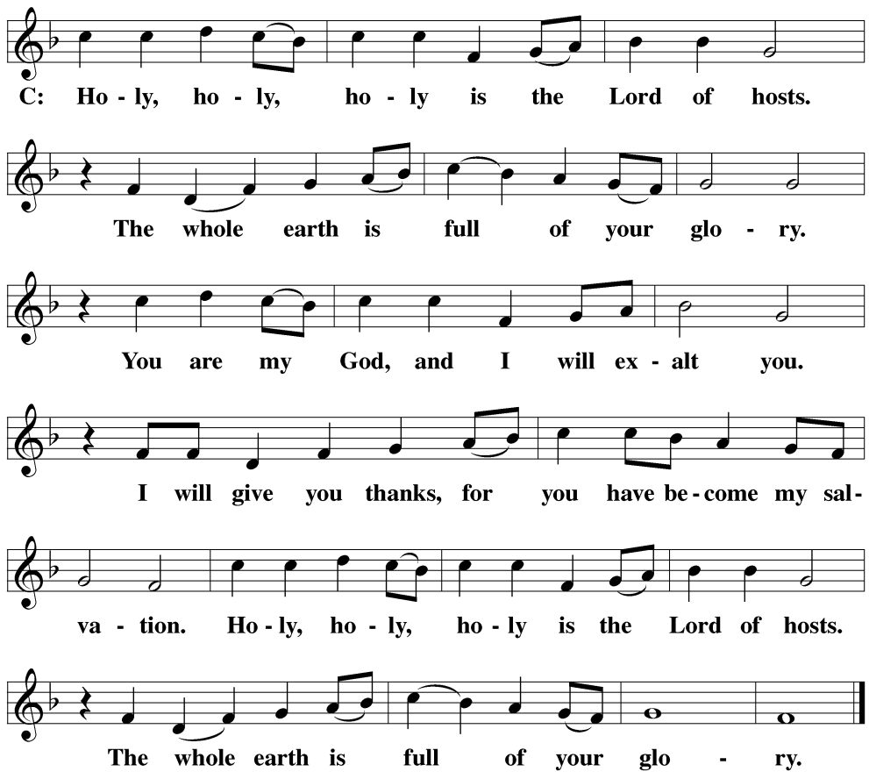
WORDS OF INSTITUTION Matthew 26, Mark 14, Luke 22
M: Our Lord Jesus Christ, on the night he was betrayed, took bread; and when he had given thanks, he broke it and gave it to his disciples, saying: “Take and eat. This is my ✙ body, which is given for you. Do this in remembrance of me.”
The Words of institution both proclaim the words of Jesus to the congregation and sets apart the bread and wine for the Lord’s Supper.
Then he took the cup, gave thanks, and gave it to them, saying, “Drink from it all of you; this is my ✙ blood of the new covenant, which is poured out for you for the forgiveness of sins. Do this, whenever you drink it, in remembrance of me.”

PEACE OF THE LORD – Pax Domini John 20:19
M: The peace of the Lord be with you always.
C: Amen

O CHRIST, LAMB OF GOD – Agnus Dei John 1:29
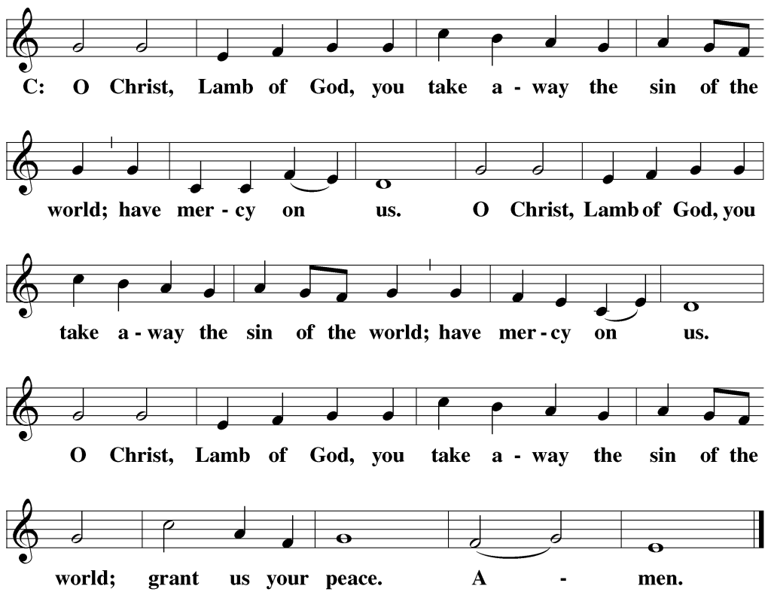

DISTRIBUTION
Those who will be receiving Holy Communion today may wish to read Personal Preparation for Holy Communion, found on page 156 in the front section of the hymnal. This page helps us put into practice what the Bible encourages: “Everyone ought to examine themselves before they eat of the bread and drink from the cup.” (1 Corinthians 11:28)
Christ Lutheran Church confesses and practices the Biblical teaching of a Closed Communion. We ask that only members of the Wisconsin Synod [WELS] or the Evangelical Lutheran Synod [ELS] join us at the Lord’s Table. If you have questions concerning our communion practice, or would like to inquire about how you, too, can commune with us, please speak with the Pastor following the service.

THANK THE LORD
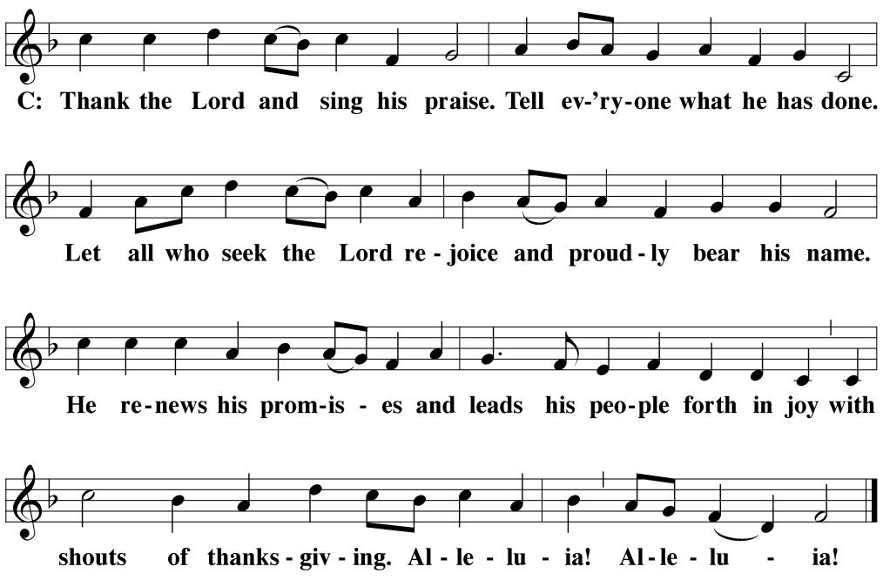
M: Hear the prayer of your people, O Lord, that the lips which have praised you here may glorify you in the world, that the eyes which have seen the coming of your Son may long for his coming again, and that all who have received in his true body and blood the pledge of your forgiveness may be restored to live a new and holy life, through Jesus Christ, our Lord, who lives and reigns with you and the Holy Spirit, one God, now and forever.
C: Amen.
THE BLESSING
M: Brothers and sisters, go in peace. Live in harmony with one another. Serve the Lord with gladness.
The Lord bless you and keep you.
The Lord make his face shine on you and be gracious to you.
The Lord look on you with favor and ✙ give you peace.
C: Amen.
CLOSING HYMN All Depends on Our Possessing| CW 421

COPYRIGHT INFORMATION
Content requiring a copyright license is reproduced under OneLicense.net #A-718312. All rights reserved. The Common Service: Texts revised from The Lutheran Hymnal, 1941. Music revised by James Engel. Scripture Quotations: From the Holy Bible, New International Version (NIV 1984), © 1973, 1978, 1984 by Biblica, Inc.

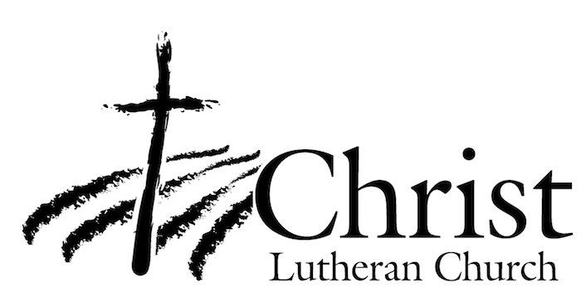
13009 N. Elderberry Ct.
Lodi, CA 95242
www.christlodi.org
209-368-6250
Pastor Tim Leistekow
WELCOME TO CHRIST EV. LUTHERAN CHURCH!
We preach a message of forgiveness, hope and peace
through the death and resurrection of Jesus Christ.
Families and individuals of all ages will find opportunities
both to grow and to serve.
Our mission statement:
Look what Christ is doing!
He binds us together in fellowship
He gathers us in for worship
He builds us up for service
He sends us out with the gospel

“Now you are the body of Christ,
and each one of you is a part of it.”
(1 Corinthians 12:27)

